January 20, 2015
A Mom’s Helping Hand of SWFL  524 SE 27th St, Cape Coral, FL 33904  Tel 239-224-0847  amomshelpinghand@yahoo.com  amomshelpinghandofswfl.com | 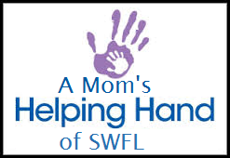

Non-Discrimination Policy

This policy states A Mom’s Helping Hand of SWFL position on discrimination. This policy applies to all A Mom’s Helping Hand of SWFL employees, volunteers, members, clients, and contractors.
A Mom’s Helping Hand of SWFL follows an equal opportunity employment policy and employs personnel without regard to race, creed, color, ethnicity, national origin, religion, sex, sexual orientation, gender expression, age, height, weight, disability status, veteran status, military obligations, and marital status.
This policy also applies to internal promotions, training, opportunities for advancement, terminations, outside vendors, members and customers, service clients, use of contractors and consultants, and dealings with the general public.

Kristen Schaufler

President

